Similar systems:
All these systems have the clients and the workers.
Upwork:
In the case of Upwork the clients (you could call them sellers) will post a job that they need to be fulfilled and price which they want to pay for the work. This is then advertised to the workers through the Upwork site. The workers (Pros) are required to write a short profile, maybe with links to their accomplishments (portfolio, maybe a GitHub in the case of computer science), skills. They also have a review page to show new clients how well they completed their past jobs. They then must apply to do the job and they will be selected by the client and a payment will be given.
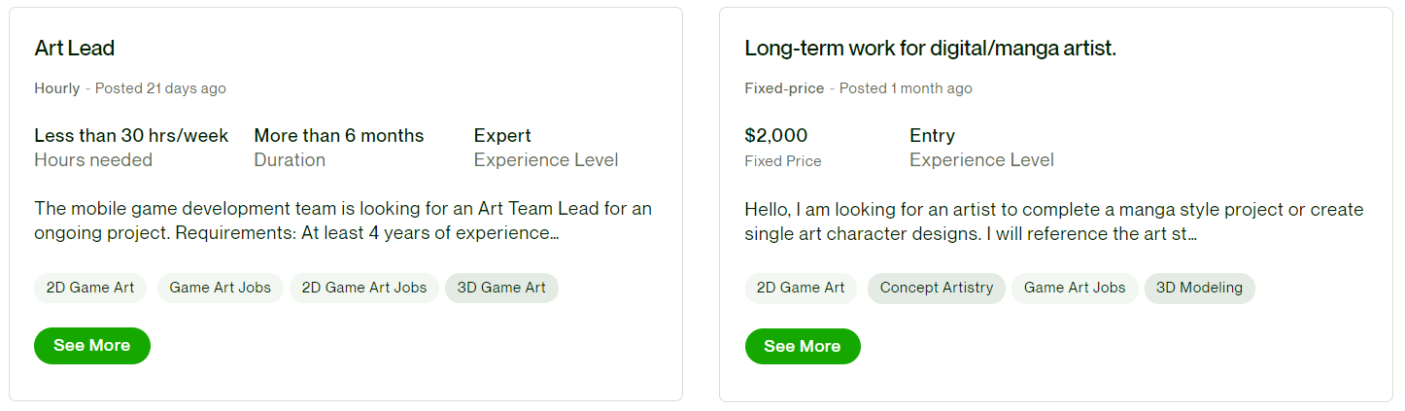
Figure 1: a screenshot showing recommended jobs on upwork
Above is an example of recommended jobs a worker could be shown.
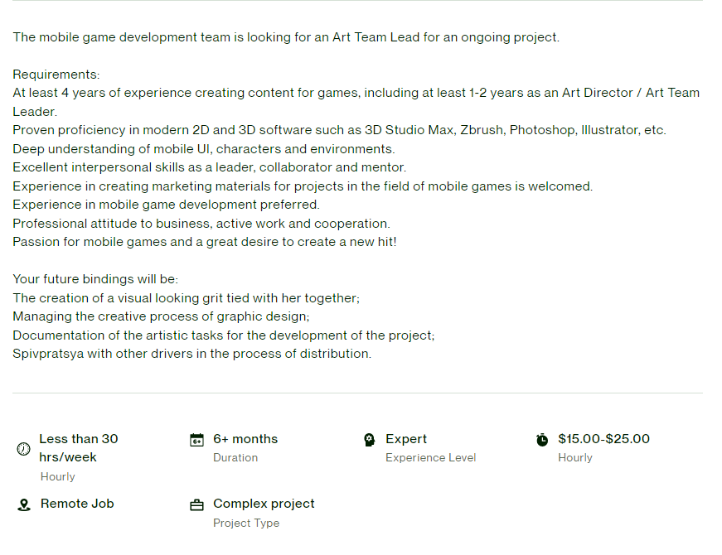
Figure 2: Showing the job description of a job on Upwork
As Upwork is freelancing for “pros” there is normally a few requirements for each job as most clients are looking for someone with a specific skillset to provide what they are looking for.
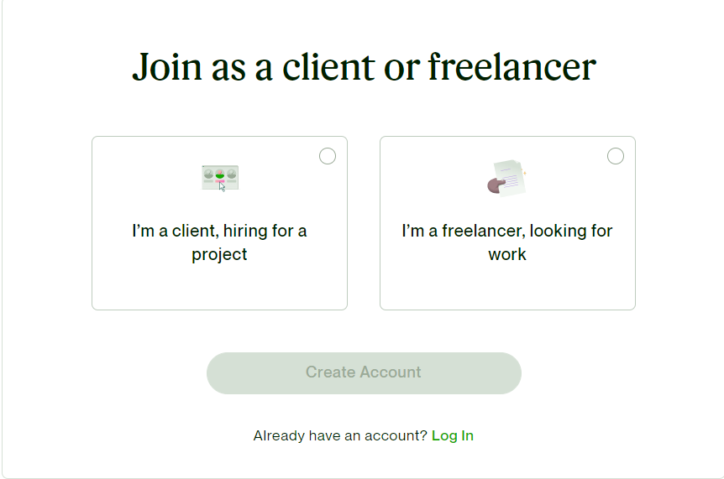
Figure 3: A screenshot of what happens when you click sign up to Upwork.
Upwork really embraces both sides of the company, as it must be successful. Therefore, it may be useful for us to develop both sides of our project simultaneously. This would also allow us to reuse and refactor our code just for the other side of the company.
Fiverr:
In the case of Fiverr, the seller will advertise their product or service and the buyer will pay a set amount of the product or service (e.g. a video edited) This is the other way round to Upwork. Buyers pay in advance when using this service. It is essentially a service advertising marketplace for people with skills that can complete these “gigs”.
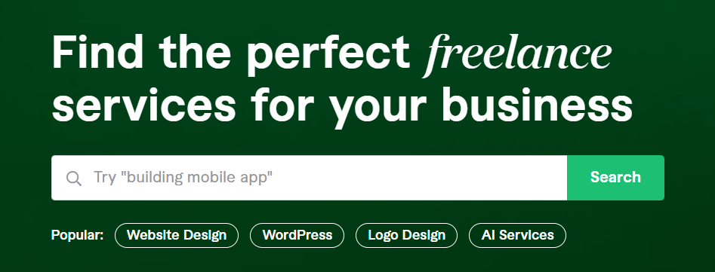
Figure 4: a screenshot of the search function fiverr
Fiverr also allows you to search for specific categories of freelance service, with lots of popular examples given to ease the user in their search.
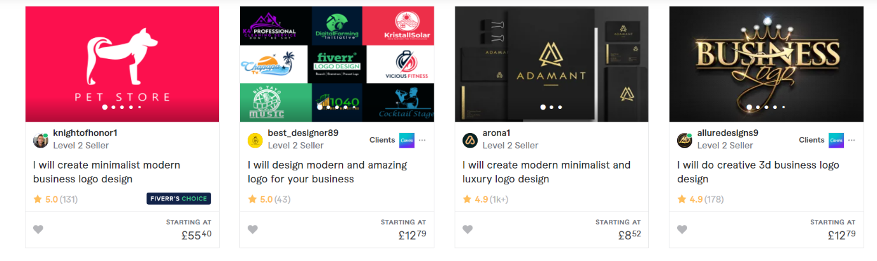
Figure 5: a screenshot of jobs if you searched for logo design
Figure 5 shows an example of services that would be shown if you were looking for someone to create a logo for you.

Figure 6: the page where you got to become a seller on fiverr
There is a huge emphasis on becoming a seller if you have a marketable skill as fiverr relies on specialists to sell their services.
On Fiverr you become a seller with your specific skill. This is the other way round to how our project would work. This is because the seller is advertising their service and the customer must pay to receive it. However, we will be offering money for a certain service to be completed. However, we could take inspiration from Fiverr and advertise certain well-respected members of our project to people who need jobs filled before they even post it publicly, almost like a sort of head hunting.

Figures 1,2,3 all show screenshots taken from Upwork’s website: https://www.upwork.com/

Figures 4,5,6 all show screenshots taken from fiverr’s website: https://www.fiverr.com/

